CS 255 System Design Document

UML Use Case Diagram

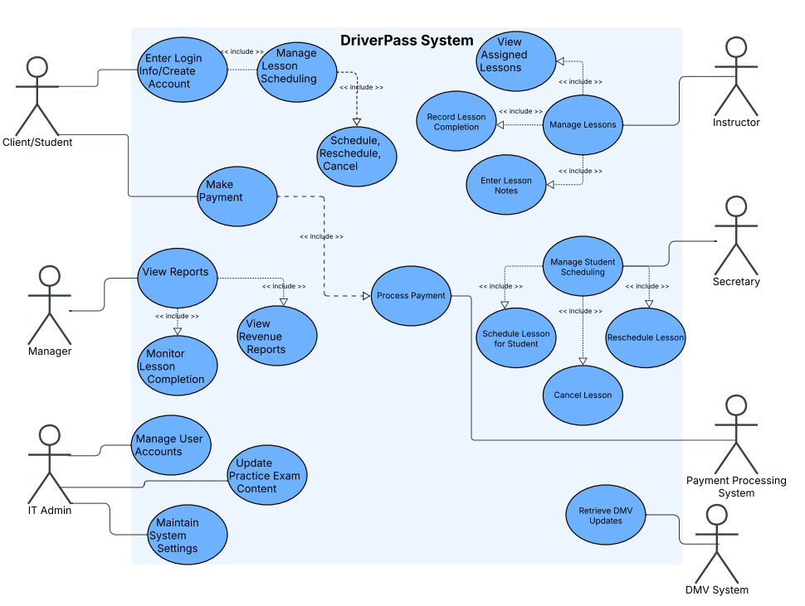

UML Activity Diagrams (1 & 2)
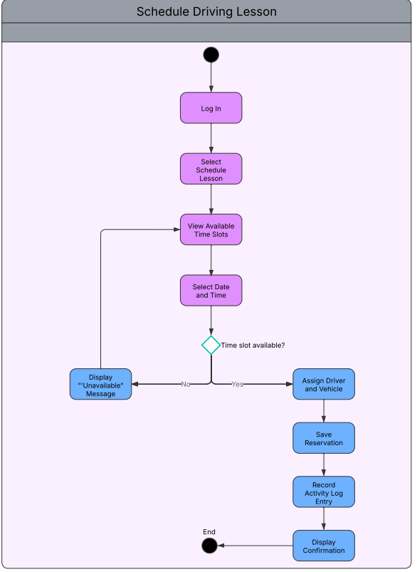

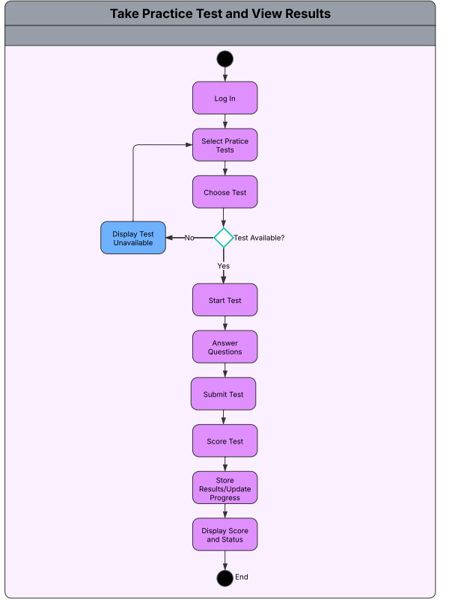

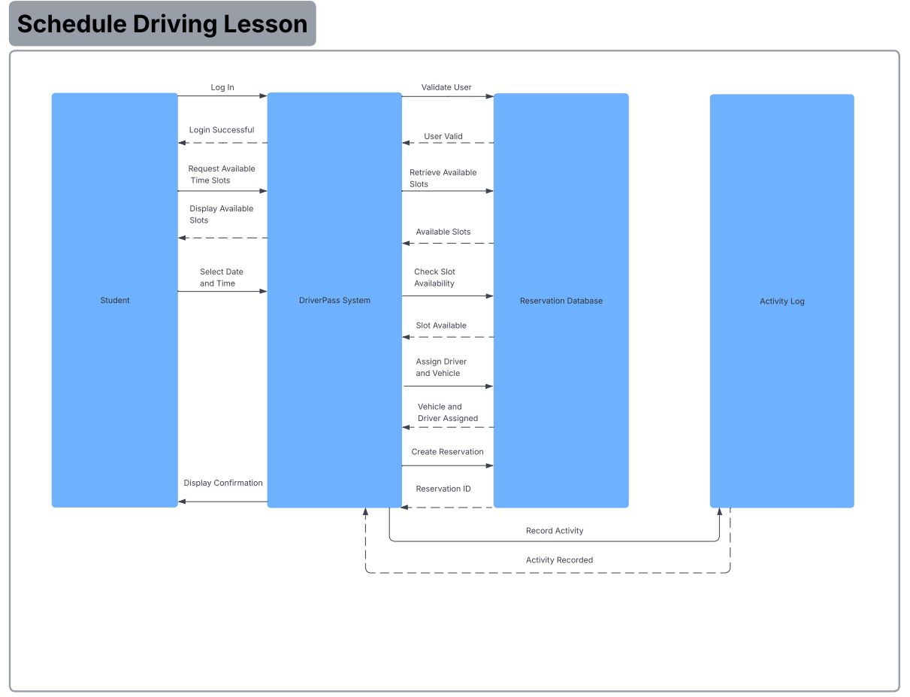
UML Sequence Diagram

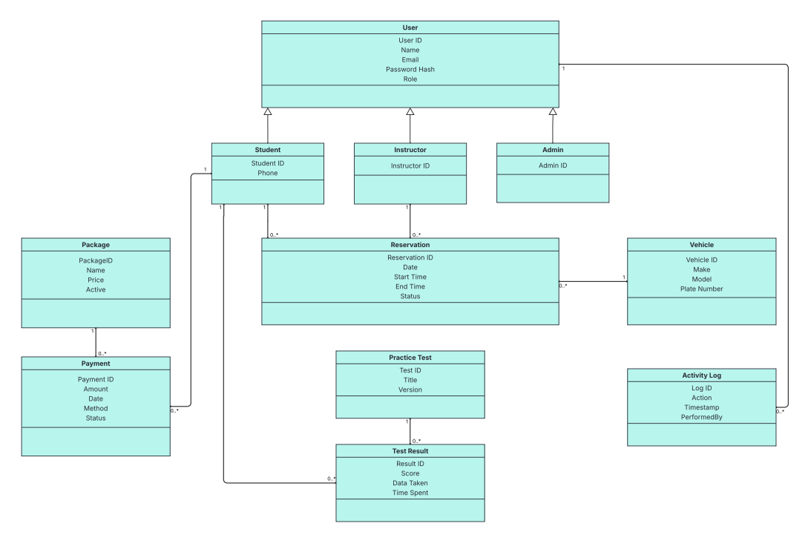
UML Class Diagram

Technical Requirements
The DriverPass system will need a cloud hosted server environment to support a web-based application that students, instructors, and staff can access from anywhere. Since the system handles scheduling, payments, and practice testing, it must be accessible through modern web browsers without requiring users to install additional software. On the hardware side, staff will use standard desktop or laptop computers, while students may access the system from either computers or mobile devices. Reliable internet connectivity is essential because the entire platform depends on real time scheduling and data updates.

From a software perspective, the system will require a backend database to securely store user accounts, lesson reservations, vehicle assignments, practice tests, test results, payments, and activity logs. The system must support secure authentication and role-based access control so that students, instructors, and administrators only see and perform actions appropriate to their roles. Since payments and personal information are involved, the system must use encrypted connections and protect stored passwords using hashing techniques. Additionally, the platform should support integration with external systems such as payment processors and DMV content updates through secure APIs.

In terms of infrastructure, the system should be scalable to handle increased usage during peak scheduling times. It should also include automated database backups and monitoring to prevent data loss and minimize downtime. Logging and reporting capabilities are necessary to track important actions such as reservation creation, updates, and cancellations, which supports both accountability and troubleshooting. Overall, the technical requirements are focused on security, reliability, scalability, and ease of access so that DriverPass can operate efficiently and grow over time.

